wk1_assign_D_php1.docx

*** Applying What You Have Learned! ***

Topic: *“Working with Constants and Variables”* (solarsystem.php)

Task #1: Download the IMAGES

* Download the images of the planets
  + File: planet_gifs.zip
    - Note: This zip file contains an image for each planet, the sun, and an image named stars.gif that may be used as a background.

Ever since the discovery of Pluto in 1930, kids grew up [learninghttp://images.intellitxt.com/ast/adTypes/icon1.png](http://www.space.com/16080-solar-system-planets.html) about the nine planets of our solar system. That all changed starting in the late 1990s, when astronomers began to argue about whether Pluto was a planet. In a highly controversial decision, the International Astronomical Union ultimately decided in 2006 to call Pluto a “dwarf planet,” reducing the list of “real planets” in our solar system to eight. But many of us still cling to the notion of nine planets.

Regardless of your view, here’s the order of the eight larger planets, starting nearest the sun and working outward through the solar system: Mercury, Venus, Earth, Mars, Jupiter, Saturn, Uranus, Neptune, *Pluto*.

Your task: Create a web page named solarsystem.php.   
  
See sample web page below:

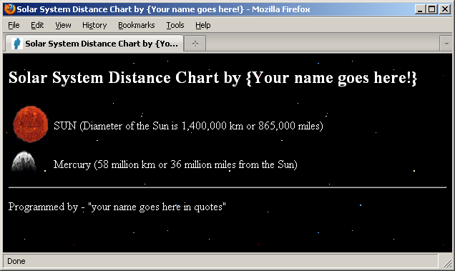

Task #2: Create the PHP program named   
 solarsystem.php

* You may design this program as you wish. Feel free to be creative.
* However, you must follow a few simple rules:

1. This program is named “solarsystem.php”.
2. You must define and use PHP constants and/or variables in this program. Four constants are defined below.

e.g. define("SUN_KM", 1400000);

define("SUN_MILES", 865000);

define("MERCURY_KM", 58);

define("MERCURY_MILES", 36);

. . .

1. Displaying the ‘solarsystem’. When you display a numeric PHP constant, it should be formatted.

e.g. <?php echo number_format(SUN_KM); ?>

1. This is a ‘Distance Chart’, so you should display the Sun first, followed by all of the planets in order of closest to furthest from the Sun.

The test to be displayed for each planet is:

Sun (Diameter if the Sun is 1,4000,000 km or 865,000 miles)

* Mercury (58 million km or 36 million miles from the Sun)
* Venus (108 million km or 67 million miles from the Sun)
* Earth (150 million km or 93 million miles from the Sun)
* Mars (227 million km or 141 million miles from the Sun)
* Jupiter (779 million km or 483 million miles from the Sun)
* Saturn (1,428 million km or 886 million miles from the Sun)
* Uranus (2,974 million km or 1,782 million miles from the Sun)
* Neptune (4,506 million km or 2,794 million miles from the Sun)
* Pluto (5,913 million km or 3,666 million miles from the Sun)
* At the bottom of the page display a comment about the solar system. “{Place your comment within quotes}”

1. Your chart may contain miles, kilometers, or both. The constants and/or variables must be displayed using PHP code. A HTML table should be used to display the chart.
2. Save as solarsystem.php
3. POST to the server and TEST!

Sample starter code shown below:

<!DOCTYPE html>

<html>

<head><title>Solar System Distance Chart</title></head>

<body style="background-image: url(stars.gif); color: white;">

<?php

{ define any PHP constants and/or variables here!)

?>

<h2>Solar System Distance Chart by {Your name goes here!}</h2>

<table>

<tr>

<td><img src="sun.gif" alt="Sun" width="56" height="56" /></td>

<td>SUN (Diameter of the Sun is <?php echo number_format(SUN_KM); ?> km or <?php echo number_format(SUN_MILES); ?> miles)</td>

</tr>

. . .

</table>

<hr />

<?php

{print your name (surrounded by double quotes) here!}

?>

</body>

</html>

wk1_assign_D_php1.docx